General
This document presents the methods you can use to create a form that has an image associated with a finding. In Part I, we will take you through a simple form building that uses an embedded imager component. In Part II, we will present what the developer needs to do to enable support of user images and hot spots in your application.
An imager component is used in a form to contain one or more images that are defined at design time. Then you can associate one of the images assigned to the imager to a form finding. When that finding is selected at run time, the imager will automatically show the assigned image for purposes of annotation.
Another function is available where you can assign rectangular hot spots to an image and associate a specific pick list to a hot spot. Then when the user clicks the hot spot at run time, the pick list will then be presented in the form’s data entry tree similar to having a pick list component on the form.
Starting in 2Q2007, the DotNet2 imager component allows the user to define a default click action other than a pick list for each hot spot. You can associate a Medcin reference identifier to a hot spot. The click action can be optioned to either enter the Medcin finding or use the finding to seed a prompt list. And another option can specify that the hot spot description should be used to invoke a word search using that description as the search words.

Part I: Designing a form incorporating an imager

Steps
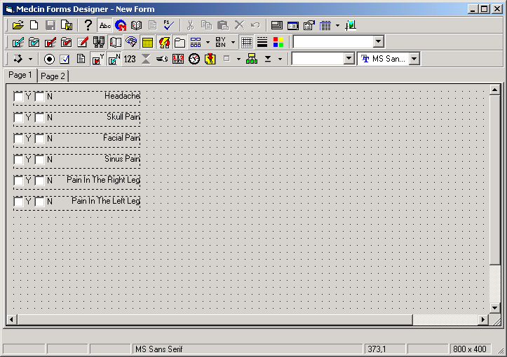
Start a new form and add the findings as shown in this image:

- Although we will not need them at first, for any tool button not already pressed, press the following tool bar buttons in the 2nd row: Search, Pick List, Prompt, Flow Sheet, and E&M. Next, select the picture tool and draw the picture onto the right hand portion. In this image, it is shown selected so the location and size can be seen in the status bar; however, size and location are not important for this exercise.
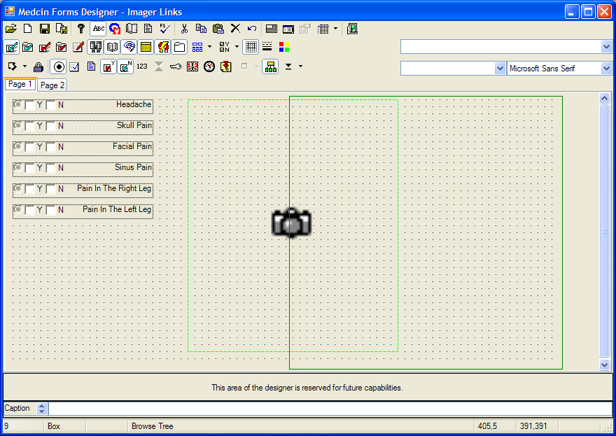
A picture component can be either a true picture or an imager. When first drawn onto the canvas, its mode is set to ‘picture’. We use the context menu to change the mode. Right click the component and select “Picture is an imager component” from the context menu. This will then present you with the property dialog box for the imager (see next page).
An image is selected using the controls within the “Image Selection” frame. The drop-down lists are used in combination with the “Male” and “Female” options to specify a Medcin image for selection. The image, if available, will be retrieved from the Medcin server when you click the “Select System Image” button. If the combination of selections does not specify an available image, you will receive an alert message. Alternatively, you can type a brief set of words into the text box that will be used to search for an image that matches any of the words when you press the ENTER key or click the search button.
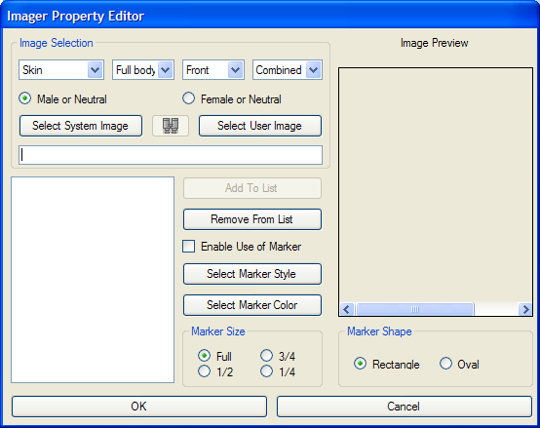
User images are provided by your application. You can choose from the application-provided images by clicking the “Select User Image” button.
Once an image is showing in the “Image Preview” window, you can assign it to the imager control object by clicking the “Add to List” button. You can preview an item in the list can be simply by clicking its entry. The selected item will appear in the preview window. When previewed, you can remove it from the list by clicking the “Remove From List” button.
This example will not be discussing the use of markers, so in this dialog, uncheck the ‘Enable Use of Marker’ checkbox. See the appropriate Medcin UI Users Guide for that topic.
Our example will want to provide an image for the head, and an image for the legs. We start by choosing Skin, Head-Neck, Front, Combined using the image selection combos and then press the ‘Select System Image’ button. Or we can type “head” into the text box, press ENTER, and choose the image from those available that match the example shown here. The image will be shown in the preview window.
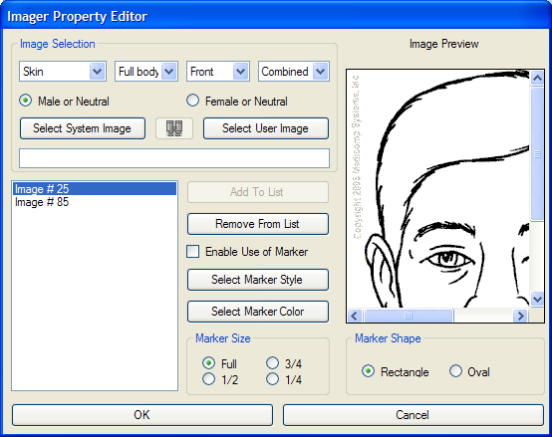
Press the ‘Add to List’ button and the image reference will be added to the list box as seen here.
Repeat this process for a selection of Skeletal, Lower extremity, front, combined” and add that to the list. This should add Image #85. Then click the OK button to close the dialog.
Now right click the ‘headache’ component, choose the ‘Property Page’ menu item, then select the ‘Imager Link’ tab. The dialog will appear as follows (this illustration uses the DotNet2 forms designer):
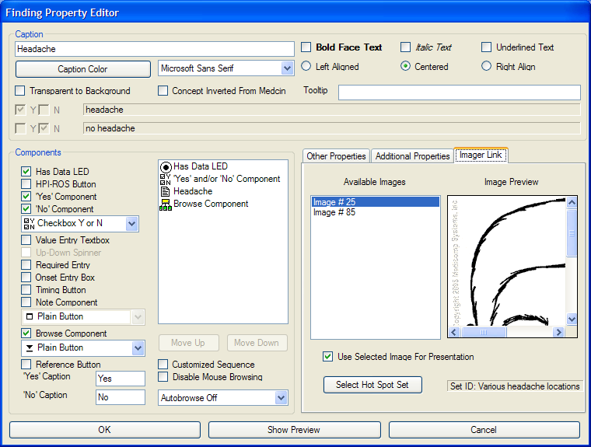
Select Image #25 that is previewed and check the box captioned ‘Use Selected Image For Presentation’. Then click the OK button to close the dialog. Repeat this procedure for the ‘skull pain’, ‘facial pain’, and ‘sinus pain’ findings. We will be discussing the use of hot spot sets in a subsequent topic in this document, so disregard the Select Hot Spot Set button at this point.
For the two leg findings, choose Image #85. Save the form with the name, ‘ImagerLinks’.
To use this form, start TestGui, select a patient, select the Active Forms tab, select the Imager Links form you just designed. If you then click the headache caption (or enter the finding using the checkbox), the imager is shown with the image that was selected in the designer.
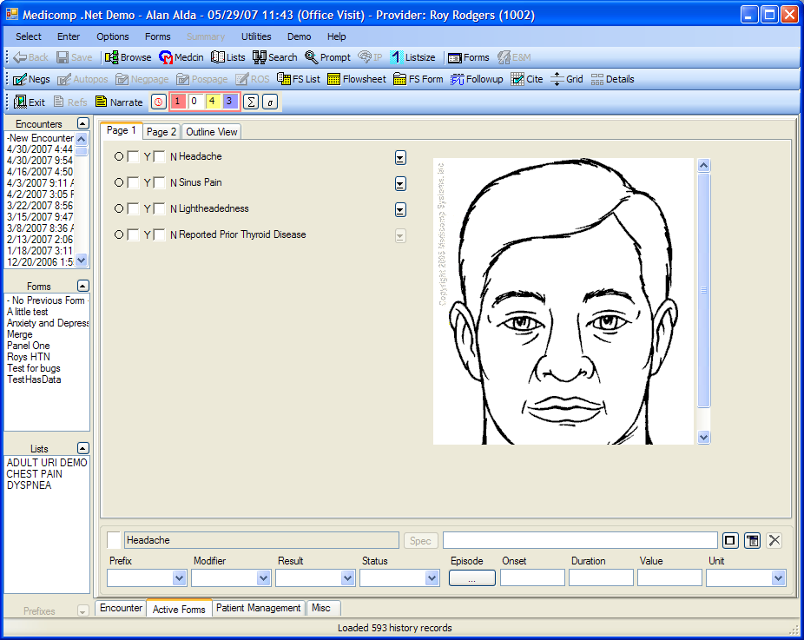
If you click on one of the leg findings, the imager presents the leg image. The user can annotate the image by choosing the ‘Show toolbar’ menu item from the imager’s context menu, then using drawing tools appropriate to what the user wants as an annotation. Annotations will be saved to the chart when the toolbar’s save button is pressed.

Making Use of Hot Spots
Hot spots are rectangular regions of that image that you define using the hot spot editor. An image can have a set of hot spots that delineate various areas of the image. With the DotNet2 Hot Spot editor, an image can have any number of “hot spot sets”. In this next example, we will add a set of hot spots that can be used to automatically enter the location of a headache when the user clicks on the hot spot. The example makes use of the DotNet2 hot spot editor.
When invoked, the editor will be presented that looks like the following illustration (without the image showing).
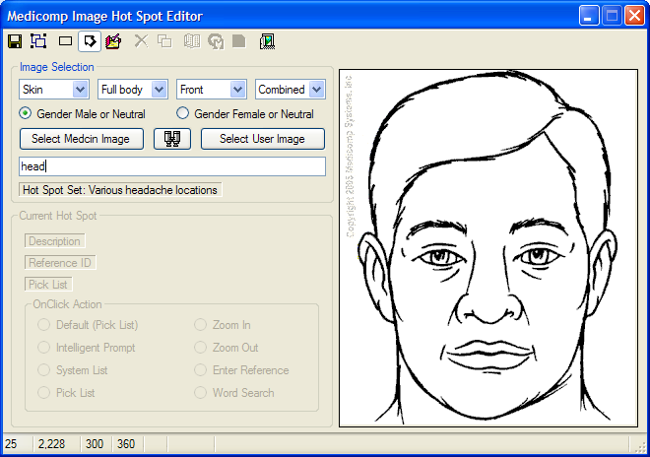
The method of selecting an image is identical to the method used in the forms designer’s imager property dialog. Here, we want to associate a set of hot spots to the head image used above. Thus, you can type “head” into the text box, then select the head image previously used. A hot spot set selector will be shown. In the textbox that shows “Enter new hot spot set descriptor here”, type in “Various headache locations” and click the OK button. Now the editor will look like the illustration.
Change the tool selected from the pointer to the hot spot drawing tool (the rectangle to the left of the pointer). Then draw four hot spots until the image looks like the following:
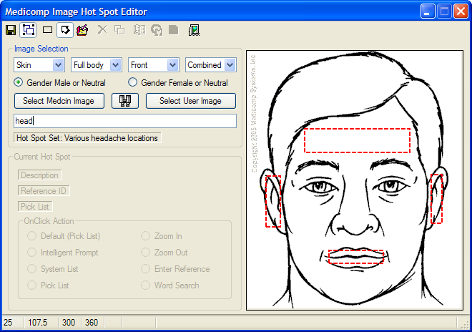
Select the “temple” hot spot by clicking on it; it will show a selection rectangle surrounding it. Next, click the Medcin tool bar button, and find the “headache over the temple” Medcin finding and select it. Also click the Description tool button and enter “temple” as the description. Choose the option “Enter Reference”.
Repeat these steps for the left and right ear. Use the “headache in front of right ear” finding and “right ear” as the description for the right ear hot spot; use the “headache in front of left ear” finding and “left ear” as the description for the left ear hot spot. Don’t forget that you are looking at the face; thus the right ear is on the left side of the image.
For the hot spot over the mouth, choose the “sore throat” Medcin finding as the reference, and “mouth” as the description. Select the Word Search option.
This completes the entering of the hot spot information in this sample. Now you have to make use of the hot spot set in the form previously created. Therefore, go back to the forms designer and select the “ImagerLinks” form. Select the headache finding, go to its property dialog, go to the Imager Link tab, and click the Select Hot Spot Set button. If the image has only one hot spot set available, that set will be used; otherwise, you will see a dialog that allows you to select one of the available hot spot sets. This action will associate the “Various headache locations” hot spot set with the image for the headache finding.
To see this in action, select a patient, and select the form you created for use with the forms module. When you click on the “headache” caption of the headache finding (you do not need to enter the finding), the image of the head will appear. As you move the mouse over the area of the image where the temple hot spot was located, you will see a tool tip that shows “Entry: headache”. This tool tip is a result of the description “headache” that you entered for the hot spot as well as the OnCLick action of “Enter Reference”. Now if you click on the hot spot, the “headache over the temple” finding will be entered and the image will disappear. You can see the result by looking at the Outline View, or by requesting a note view.
Notice that if you click on the hot spot area for the mouth, the form will show a word search using the description “mouth”. This will look like the following.
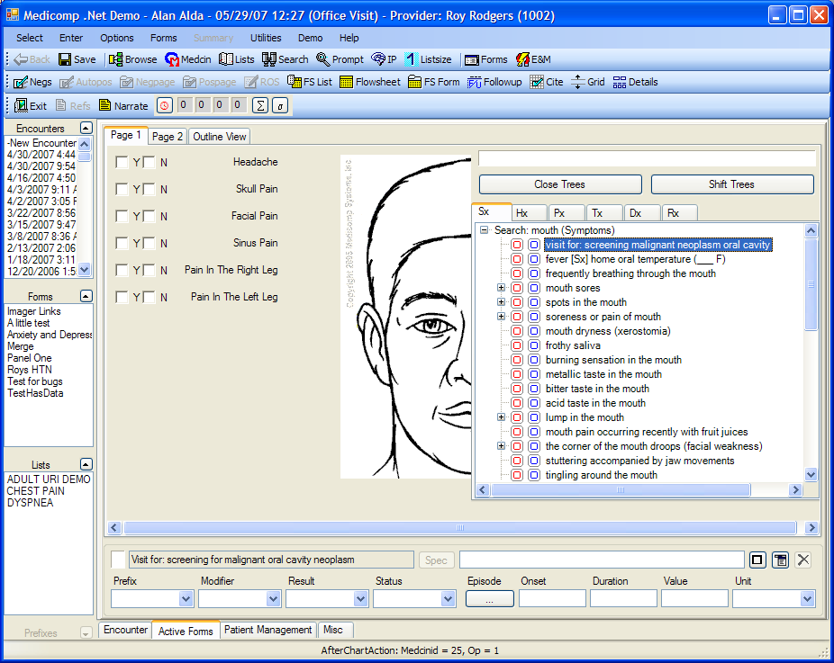
Regardless of what OnClick action you chose in the hot spot editor, you can right click a hot spot and choose one of the available actions from its right click context menu.
By a careful design of hot spots and the hot spot set data associated with a set, you can create many hot spot sets that target a specific purpose; each set can be tied to a particular finding on the form.

Part II: Incorporating User Images and Hot Spots

HotSpot Editor
In the HotSpot editor, communication about user-provided images and hot spot data between the module and the application is handled through asynchronous notifications using call-back methods. These methods are contained in the IMedImager interface that your application must implement. Your application provides an object that implements IMedImager and passes it to the editor by calling the EnableUserImages method; the IMedImager interface object is passed as a parameter. Even if you are not supporting user images, you must implement the interface and call the method. Let’s take a look at this interface.

The IMedImager Interface
This interface is used in three different modules that pertain to three different functionalities. Source code for an example of an implementation of the interface can be found in the TestGUI fmain.vb source code file in the CMedImager region. Whenever the application needs to differentiate the purpose of the method called, the parameters will provide the mode. The three modules are:
- The HotSpot Editor, where the mode is ‘Edit’.
- The Forms Designer, where the mode is ‘Design’.
- The Forms module, where the mode is ‘Run’
Sub QueryImage(ByRef UserImageID As Integer, ByVal ImageSystem As Medicomp.Constants.medImageSystem, ByVal ImageRegion As Medicomp.Constants.medImageRegion, ByVal ImageView As Medicomp.Constants.medImageView, ByVal ImageAgeBand As Medicomp.Constants.medImageAgeBand, ByVal ImageSex As Medicomp.Constants.medImageSex, ByVal ImageAttribute As Medicomp.Constants.medImageAttribute)

The QueryImage method is called when the user clicks the “Select User Image” button in the HotSpot editor. What the application needs to do is to show a dialog that allows the user to select an application provided image. The parameters reflect the current settings of the HotSpot editor controls and may be useful to filter available images for selection. When a selection is made, the positive value numerical image identifier is placed in the UserImageId argument of the method.
Note that the method is used only to get the identifier of the image. The method does not provide the image; the editor will obtain that when needed by calling RequestImage.

Sub RequestHotSpotList(ByVal Parms As Medicomp.Objects.HotSpotSetParms)
This method will be called when ever an image is selected, be it a Medicomp image or a User image. Its purpose is to obtain the current list of hot spot sets from the application’s database. The properties of the Parms object in this case are: the mode property is ‘Edit’, the ImageID property is the ImageID of the image, and the HotSpotSetID property is -1. Note that to differentiate between user images and Medicomp-provided images, the ImageID here will be negative for user images and positive for Medicomp images.
If the user selects an existing set, place the numerical ID of the set into the HotSpotSetID property, the descriptive caption for the set into the SetDescriptor property, and the data string of the set into the SetData property. If the image has no hot spot set data in your database, you should initialize the HotSpotSetID parameter with a 0, and add a string for the SetDescriptor.
Sub RequestImage(ByVal UserImageID As Integer, ByRef Picture As System.Drawing.Image)
The HotSpot editor makes use of a MedImager control for displaying images. The method will be called when the control needs to display a user-provided image. Essentially, the control raises a RequestImage event which is handled by the editor; the editor then calls the RequestImage method of the interface object. Since this method is only called to obtain a user-provided image, the UserImageID in this case will be a positive number. This is in contrast to the RequestHotSpotList that needs to obtain data on either user images or Medicomp images.
Your application needs to obtain the image in question as a System.Drawing.Image object and place it in the Picture parameter of the method call.

Sub SaveHotSpotList(ByVal Parms As Medicomp.Objects.HotSpotSetParms)
The actual editing of the hot spots on an image is handled by the MedImager control that is hosted by the HotSPot editor. When the user has made changes to the hot spot set currently being edited and selects the ‘Save’ button, the editor calls the SaveHotSpots method of the imager control. The Imager control in turn saves the data to a packed string and raises an ImagerSave event that passes the data in its Annotation property. The editor handles this event by updating the current HotSpotSetParms object’s SetData property. The ImageID and HotSpotSetID properties are current based on the hot spot set under edit; the Mode property remains ‘Edit’. It then calls the SaveHotSpotList method of the interface passing the HotSpotSetParms object.
Your application should have all of the needed properties to update your database with the data contained in the Parms parameter.

The IDialog Interface
One of the interfaces used for communicating with the HotSpot editor is the IDialog interface. This interface is documented in the MedcinDotNetUIDevelopersGuide and will not be repeated here. In the TestGUI fMain.vb source code, the ListEditor region has code that implements this interface.

The IListIOLoader Interface
Another interface that the application needs to support for the HotSpot editor is the IListIOLoader interface. This is used to handle communication for identifying pick lists. This interface is documented in the MedcinDotNetUIDevelopersGuide and will not be repeated here. However, we will provide the use made of this interface to ensure that your application provides the support needed for used with the HotSpot editor. In the TestGUI fMain.vb source code, the ListEditor region has code that implements this interface.
There are two cases where the HotSpot editor will raise a PickListIO event:
- When the user clicks the ‘Select Picklist’ button, the editor will raise a PicklistIO event. The List property of the event argument will be a new MedPicklists object. The Mode property will be plmSearchListNames. On this event, the application needs to provide the user a dialog to select an existing list. Add a MedPicklist object to the List property; at this point, it is not necessary to obtain the actual list of items. Only the ListID property of the MedPicklist object needs to be entered; however, it may be useful to enter the ListSID property (if supported in your application) to ease future enhancements. It is not necessary to enter the ListName, Listroup, or ListOwner properties as the HotSpot editor makes no use of them at this point.
- When the user selects a hot spot on the image, the imager control raises the ImageHotSpotSelected event. The editor uses the data from this event to update its context presentation for the hot spot. If a hot spot is selected that has a non-zero PickListID associated with it, the editor raises a PickListIO event. The List parameter contains a new MedPicklists object that contains one MedPicklist object with its ListID property set to the PickListID property of the hot spot; the Mode is set to plmGetListTitle. For this request, the application needs to obtain the title of the list and place that in the ListName property of the MedPicklist object. This is used simply to display a name for the list in the editor’s dialog.

Forms Designer
In the Forms designer, communication about user-provided images between the module and the application is handled through asynchronous notifications using call-back methods. These methods are contained in the IMedImager interface that your application must implement. Your application provides an object that implements IMedImager and passes it to the forms designer by calling the EnableUserImages method; the IMedImager interface object is passed as a parameter. Even if you are not supporting user images, you must implement the interface and call the method if you wish to support hot spots. The interface was previously discussed, so here we will take a look at those methods used by the forms designer. In the TestGUI fMain.vb source code, the CMedImager region has code that implements this interface.
- QueryImage: When the user clicks a button or menu item to select a user-provided image, the forms designer will call this method. The application needs to handle this request exactly the same as for the HotSpot editor. An application dialog allows the user to select an image and the positive numerical identifier of the image is placed in the UserImageID parameter.
- RequestImage: Any time the designer needs to present an image that is a user-provided image, it will call the RequestImage method passing the positive numerical value of the user image identifier. This is the same functionality as used in the HotSpot editor. Your application needs to obtain the image in question as a System.Drawing.Image object and place it in the Picture parameter of the method call.
- RequestHotSpotList: There are two different cases where the RequestHotSpotList method will be called. Your application can differentiate between the cases by checking the properties of the HotSpotSetParms parameter.
- When the user is editing the properties of a finding object, has the ‘Imager Link’ tab showing and presses its ‘Select Hot Spot Set’ button, this method will be called. The Parms object will have the following properties: the ImageID will be the identifier of the image (negative values imply a user image while positive values imply a Medicomp image); the HotSpotSetID will be -1; the Mode will be ‘Design’. Your application needs to provide a mechanism that allows a user to select an existing hot spot set. If only one set exists, you can make that selection silently (the TestGUI fMain.vb uses this technique).
- When the user edits the properties of a finding object that has an image reference with a HotSpotSetID property (>=0), this method will be called to obtain the SetDescriptor for display in the dialog. In this case, the Parms object’s HotSpotSetID property will not be -1, but will contain the identifier of the hot spot set assigned to the finding for the associated image. To respond to this request, simply obtain the SetDescriptor.
The Forms designer also needs the application to support the IListIOLoader interface to allow requests for lists to be handled. This interface is documented in the MedcinDotNetUIDevelopersGuide and will not be repeated here. PickListIO events raised here have nothing to do with hot spots or images. However, we will provide the use made of this interface to ensure that your application provides the support needed for used with the Forms designer. In the TestGUI fMain.vb source code, the ListEditor region has code that implements this interface.
- When the user performs an operation to select a pick list, the designer raises a PickListIO event with the following data: the List property is a new empty MedPicklists object; the Mode property is plmSearchListNames. The designer expects your application to add a MedPicklist object to the List object with the ListID and ListName properties filled with data at a minimum. If your application is supporting the use of the ListSID, then the list’s String Identifier (GUID) should be placed into that property as well. At this time, there is no need to retrieve the actual list items of the list.
- If a selected list is to be assigned to a pick list object that contains an internal drop down list, then the designer needs to obtain the list items. This is accomplished by the designer raising a PickListIO event with the following data: the List property is a MedPicklists object that contains one MedPicklist. The MedPicklist properties will include the ListID, the ListSID (if previously provided), and the ListName. Your application needs to obtain the items of the list and add them to the ListItems property. The designer only makes use of the Medcinid property of each item at this point.
- If the user has the search dialog open and wants to select a list, the designer will raise a PickListIO event passing a new empty MedPicklists object with the Mode set to plmGetLists. Since the MedPicklists.Item count is 0, your application should provide a dialog that queries the user to select a list. Then your application should add, to the MedPicklists object, a MedPicklist object that has the list items. Note that you now have to call the LoadPicklist method of the IListIOLoader interface to get the list of items into the search dialog as this is not handled by the procedure that raises the PickListIO event.

Forms Module
In the Forms module, communication about user-provided images and hot spot sets between the module and the application is handled through asynchronous notifications using call-back methods. These methods are contained in the IMedImager interface that your application must implement. Your application provides an object that implements IMedImager and passes it to the forms module by calling the EnableUserImages method; the IMedImager interface object is passed as a parameter. Even if you are not supporting user images, you must implement the interface and call the method if you wish to support hot spots. The interface was previously discussed, so here we will take a look at those methods used by the forms module (runtime). In the TestGUI fMain.vb source code, the CMedImager region has code that implements this interface.
- RequestImage: Any time the forms runtime has an imager control that needs to present an image that is a user-provided image, it will call the RequestImage method passing the positive numerical value of the user image identifier. This is the same functionality as used in the HotSpot editor. Your application needs to obtain the image in question as a System.Drawing.Image object and place it in the Picture parameter of the method call.
- RequestHotSpotList: When an image has been selected into an imager control on a form page and the associated finding has an annotation string assigned, the imager will show the annotated image. If the finding does not have an assigned annotation but the finding properties include a HotSpotSetID, then the forms runtime will call the RequestHotSpotList method of the IMedImager interface object with the following properties for Parms: the Mode is ‘Run’, the ImageID is the identifier of the image (negative values imply a user image while positive values imply a Medicomp image), and the HotSpotSetID will be the identifier of the set. Your application should retrieve the set’s data and place it in the SetData property.
The Forms module also makes use of PickListIO events, however in the forms module, the event is part of the IGUIModule interface. This interface is documented in the MedcinDotNetUIDevelopersGuide and will not be repeated here. PickListIO events raised here have r4elationships to form picklist objects as well as with hot spots on images. We will provide the use made of this event to ensure that your application provides the support needed for used with the Forms runtime for both form picklist objects as well as image hot spots. In the TestGUI fMain.vb source code, the MedClient_PickListIO method handles the event.
- When a MedForm object is loaded into the forms module, the forms runtime creates a new MedPicklists object. A MedPicklist object is added to MedPicklists items collection for each picklist object within the form that is not presented as an internal drop down list. The ListID and ListName are populated, as well as the ListSID if available. After looping through all of the form items, the forms runtime raises a PickListIO event passing the MedPicklists object that contains one or more MedPicklist items, using a Mode of plmGetLists. Your application should add the list items to each of the MedPicklist objects; you must cycle through the entire count of items to ensure that you get the lists for each and every item. Note that you now have to call the LoadPicklist method of the IGUIModule interface to get the list of items into the search dialog as this is not handled by the procedure that raises the PickListIO event. When you do that, make sure that you are passing the MedPicklists object that was the List property of the PickListIO event parameter.
- A form may also support the PicklistSelect menu command, which is command on your application’s menu bar or toolbar that is used to initiate the selection of a pick list. Your application would handle this by calling the module’s MenuItemSelected method with a MenuID of PickListSelect. In response to this command, the forms runtime raises a PickListIO event similarly as just noted; however, in this case the MedPicklists object contains no items. Your application needs to show the user a dialog to select a list. After selection, add a MedPicklist object along with the list items to the list and call the LoadPicklist method of the IGUIModule interface.
- A form that has an imager component may have findings associated with an imager that have one or more hot spots that may have assigned pick lists. Recollect that the identification of a pick list in a hot spot at this time is only the ListID; hot spot data does not currently include the ListSID. If an imager is presenting an image and the user clicks on a hot spot where the default action is picklist (or otherwise requests that action), then the forms runtime will raise a PickListIO event passing a MedPicklists object that contains one MedPicklist; the ListID property has the list identifier and the ListItems property is an empty MedPickListItems object. Your application should obtain the list’s items from your database and add them to the ListItems property. Then you will need to call the LoadPicklist method of the IGUIModule interface.

